Mahatma Students Club celebrated birth day of P. Bhavani II B. Com student on 13.07.2022
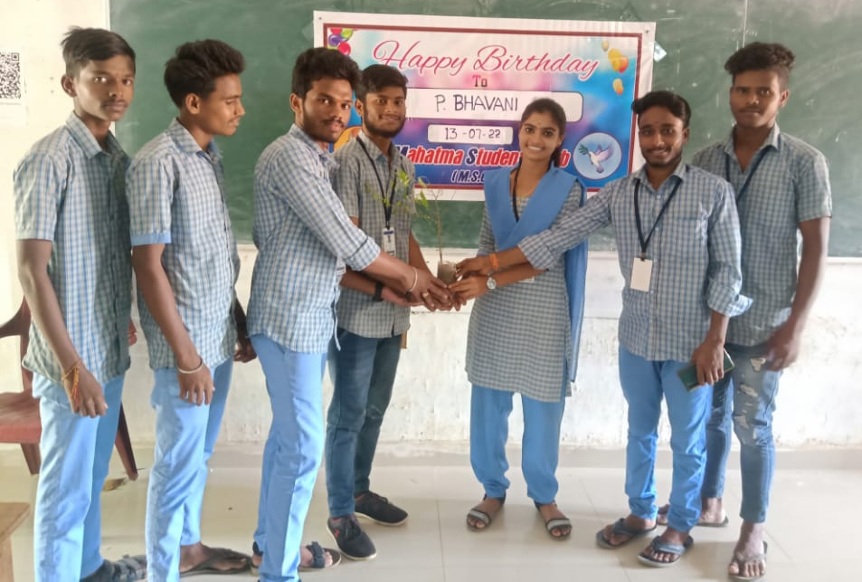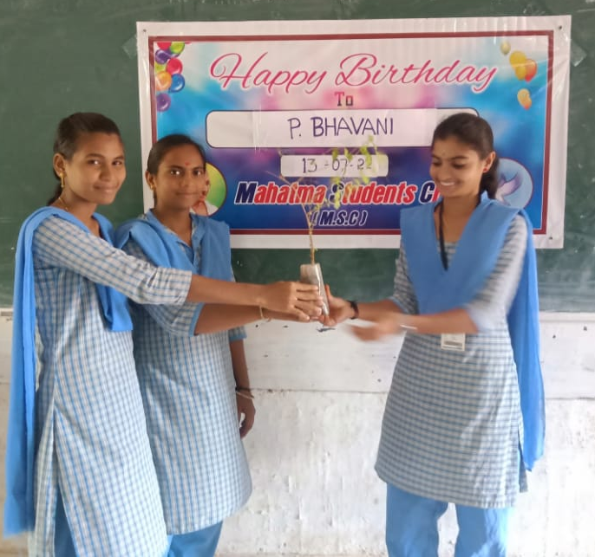

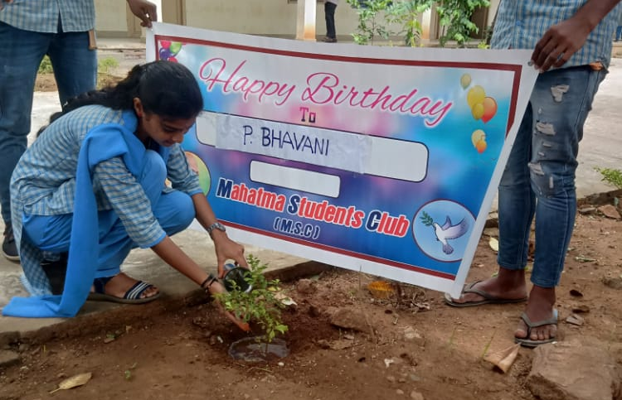

CH.KANAKA MAHALAKSHMI’S (STUDENT OF II B.COM) BIRTHDAY WAS CELEBRATED ON 01.8.2022 BY HER CLASS MATES BY DONATING PLANT. SHE PLANTED THE SAPLING IN THE COLLEGE CAMPUS AND
TOOK RESPONSIBILITY TO ITS GROWTH

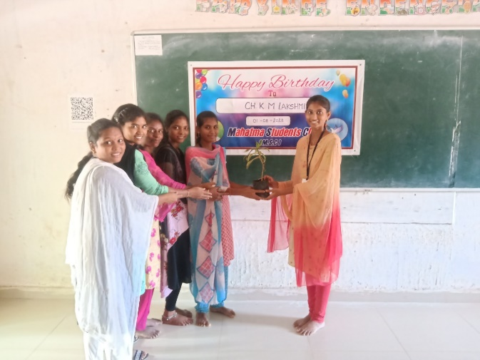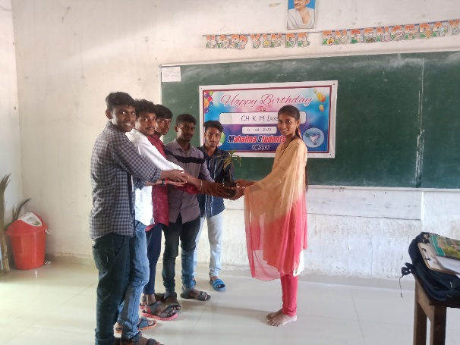

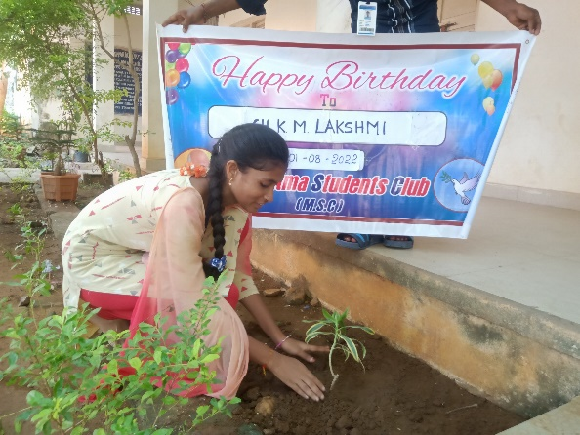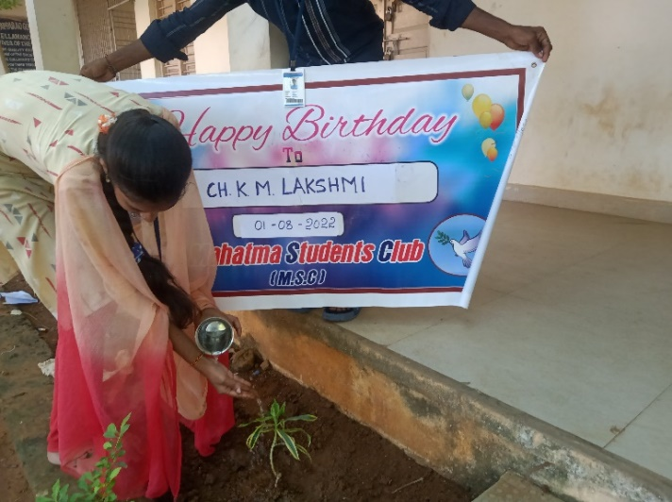

G.SURYA LAKSHMI’S (2ND B.COM) BIRTHDAY WAS CELEBRATED ON 03.8.2022 BY HER CLASS MATES BY DONATING PLANT. SHE PLANTED THE SAPLING IN THE COLLEGE CAMPUS AND
HAS TAKEN RESPONSIBILITY TO ITS GROWTH

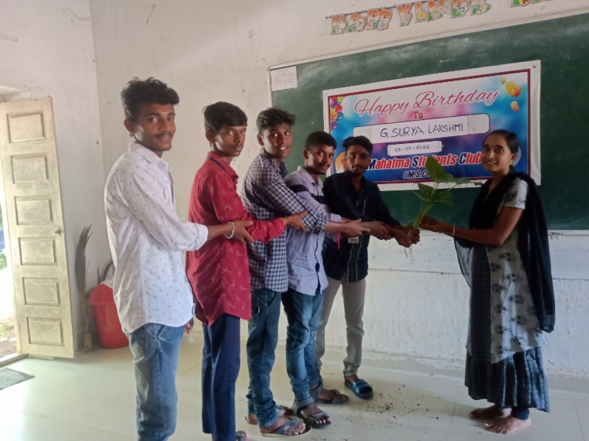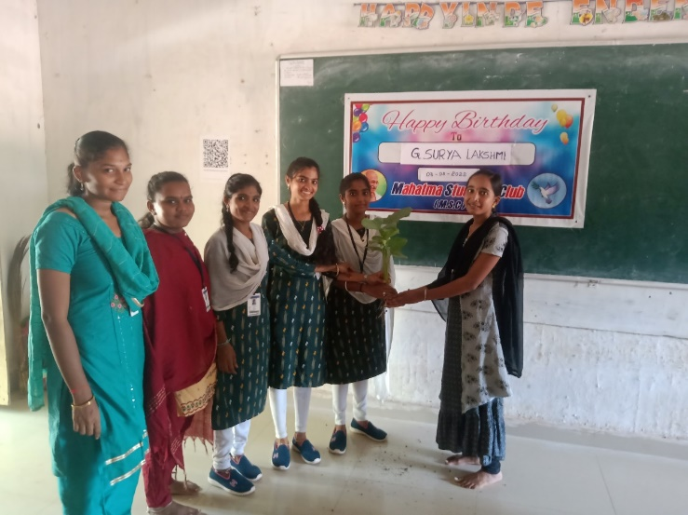

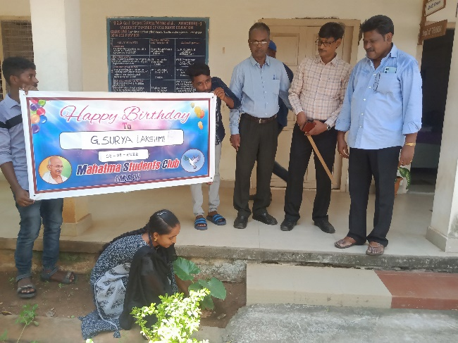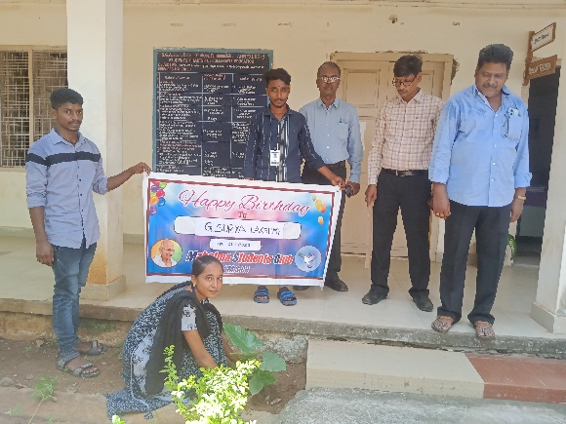

G.NAGA LAKSHMI’S ( II B.COM) BIRTHDAY WAS CELEBRATED ON 15.8.2022 BY HER CLASS MATES BY DONATING PLANT. SHE PLANTED THE SAPLING IN THE COLLEGE CAMPUS AND
HAS TAKEN RESPONSIBILITY TO ITS GROWTH

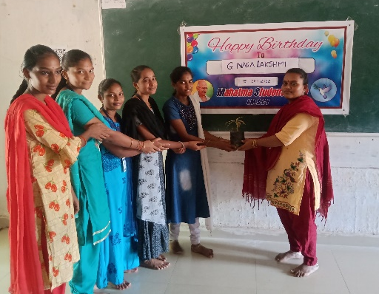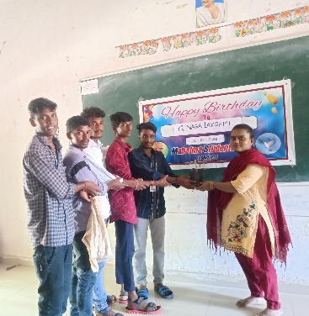

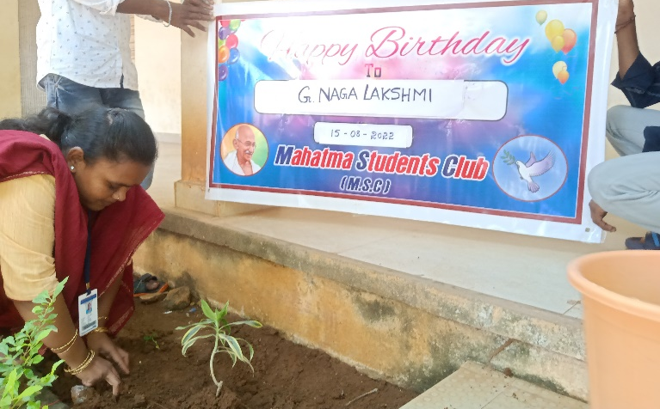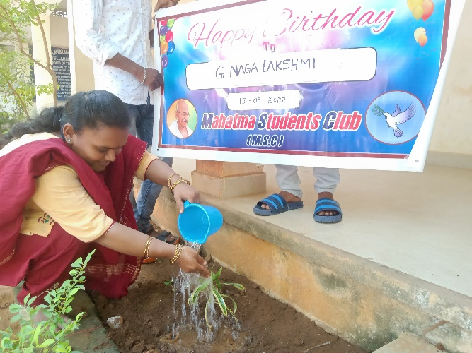

K. PRAVALLIKA DEVI’S (2NS B.COM) BIRTHDAY WAS CELEBRATED ON 16.8.2022 BY HER CLASS MATES BY DONATING PLANT. SHE PLANTED THE SAPLING IN THE COLLEGE CAMPUS AND
HAS TAKEN RESPONSIBILITY TO ITS GROWTH

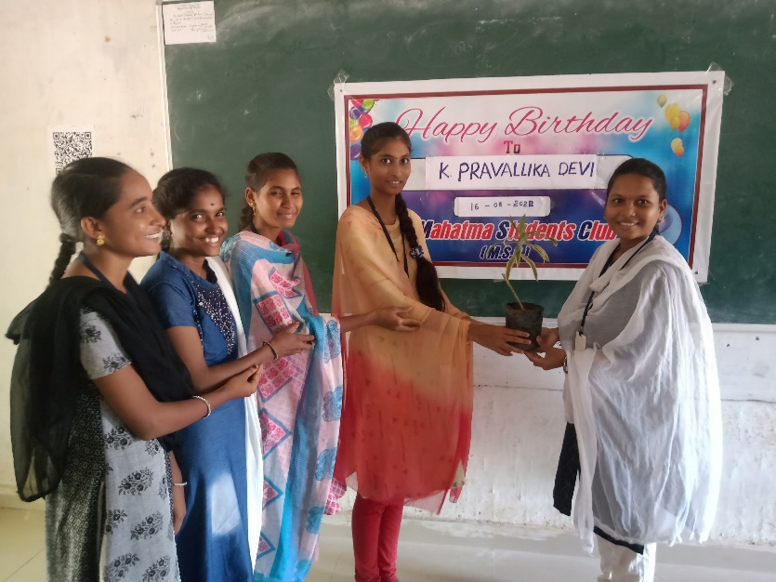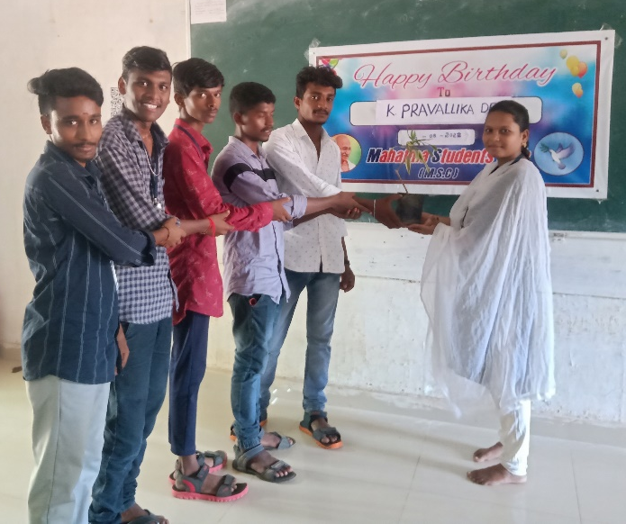

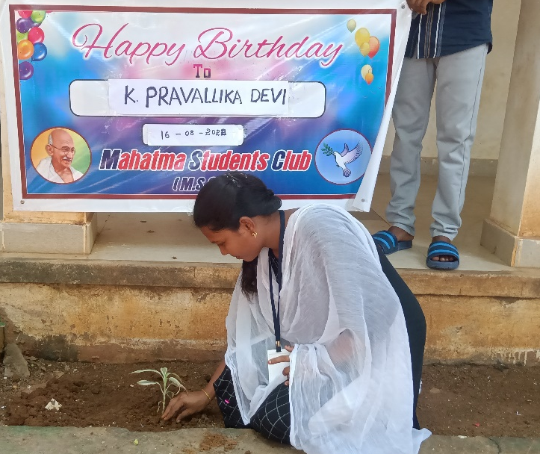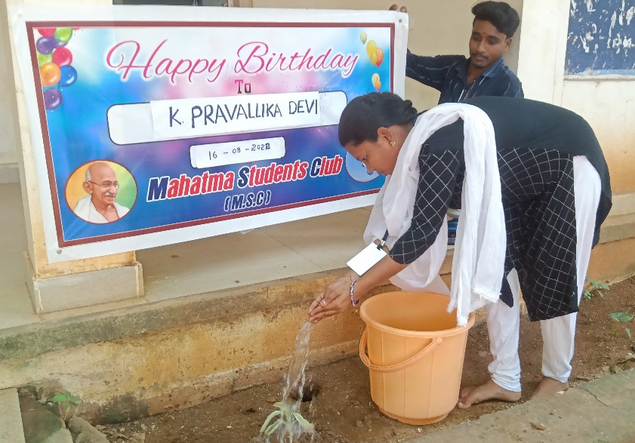

U.NAVEEN (2ND B.COM) BIRTHDAY WAS CELEBRATED ON 15.9.2022 BY HER CLASS MATES BY DONATING PLANT. HE PLANTED THE SAPLING IN THE COLLEGE CAMPUS AND
HAS TAKEN RESPONSIBILITY TO ITS GROWTH

